

*EE463 – Static Power Conversion - I*

TERM PROJECT FINAL REPORT

Cemre Yüce 2517381

Elif Çağla Kılınç 2575629

Mehmet Salih Kibar 2443414

Mustafa Aytunç Evlice 2516177

TABLE OF CONTENTS

Introduction 3

Problem Statement 3

Topology Selection 4

Component Selection 4

Results 5

Open Loop Realistic Simulations 5

Closed Loop Control Realistic Simulations 10

Transfer Function Calculation using System Identification Tool in MatLab 10

PCB Design 13

Conclusion 15

# Introduction

In the DC motor drive hardware project, it is aimed to drive a DC motor with a rectifier+converter topology effectively. The topology has been selected as a three-phase rectifier and buck converter. In the first phase of the project, a bridge rectifier and open-loop buck converter connected to it is simulated in Simulink with a DC Machine block model at the load. Moreover, an analog gate driver circuit is also implemented in LTspice with NE555 timer and LTP5702 optocoupler to drive the MOSFET of the buck converter. For the second phase of the project, we designed a PID controller through Simulink in order to drive the MOSFET gate with a feedback loop that is taken from the output of the buck converter in order to drive the DC motor safely. Moreover, the components for the driver were selected so that the analytical and computational calculations matched. Finally, the schematic of the designed DC motor driver has been constructed and the PCB layout has been drawn while concerning the practical usage. The 3D model of the components were included.

Hence, through this report, the problem statement, topology selection, open loop and closed loop simulation results and PCB layout and 3D model of the circuit will be explained.

# Problem Statement

This project aims to design an efficient system to convert AC power into a stable DC voltage for driving a DC motor. The system will use a rectifier to convert AC power from the Turkish grid into DC, followed by a buck converter to adjust and regulate the DC voltage. The power input will be a three-phase AC grid, which is adjustable using a variac. The system should provide stable DC output with the following specifications: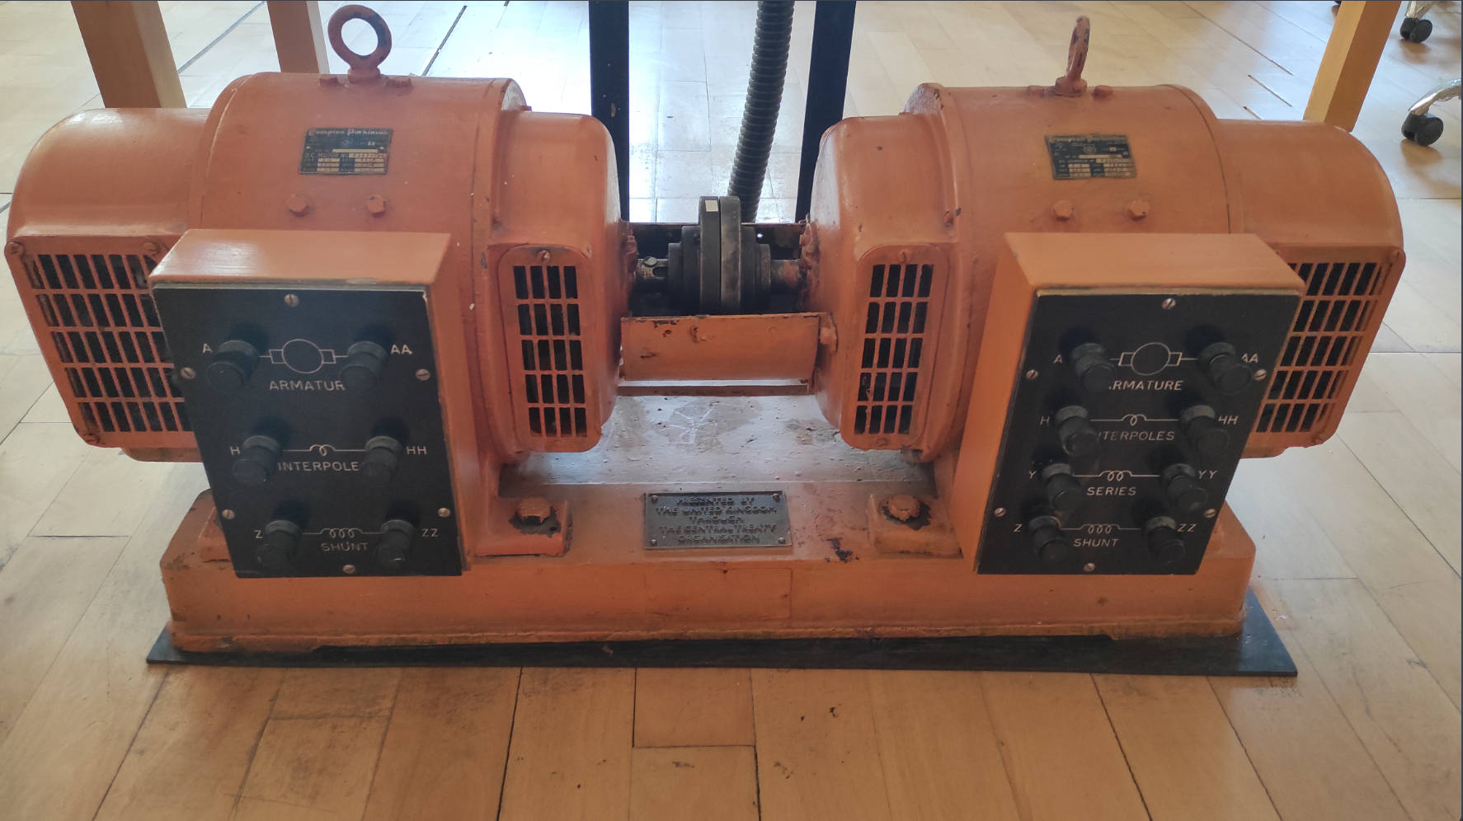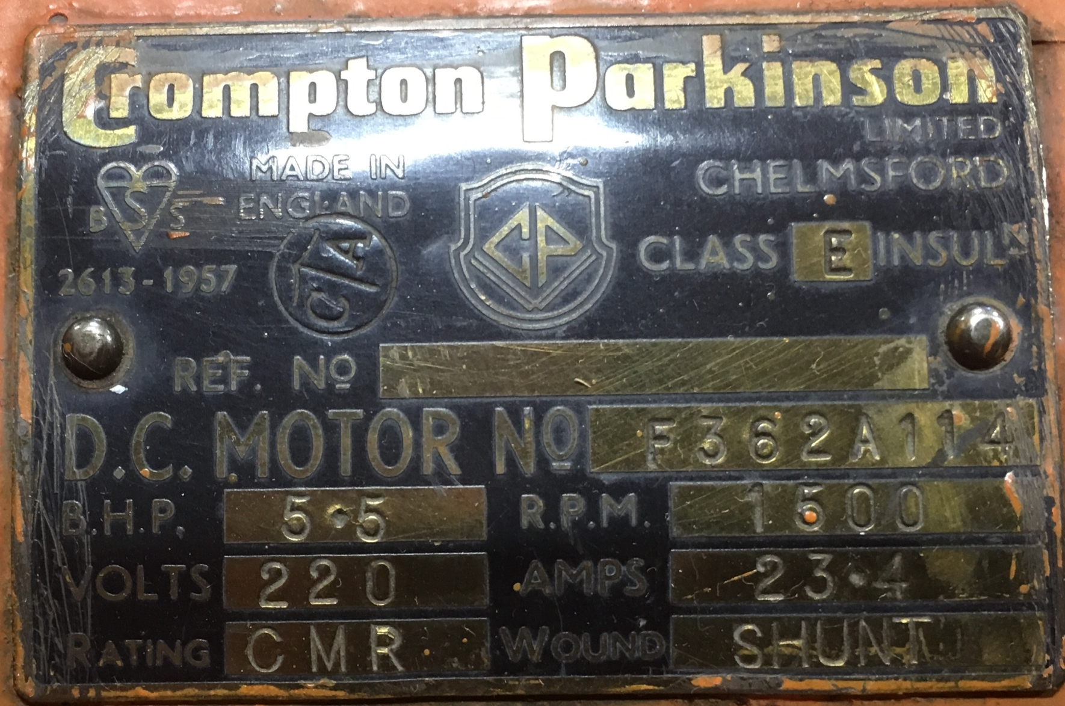

* **Power Input:** Single-phase or three-phase AC grid (Turkish Grid System)
* **Maximum DC Output Voltage:** 180 V
* **Adjustable Output Voltage:** Yes

**Machine Properties:**

* **Armature Winding:** 0.8 Ω, 12.5 mH
* **Shunt Winding:** 210 Ω, 23 H
* **Interpoles Winding:** 0.27 Ω, 12 mH

# Topology Selection

A three-phase diode rectifier + buck converter circuit topology will be used for driving the motor since it provides a higher efficiency and a lower voltage ripple in comparison with other converter topologies. The topologies we selected were studied in depth during the course which allowed us to go along with the design and implementation process with more knowledge and intuition.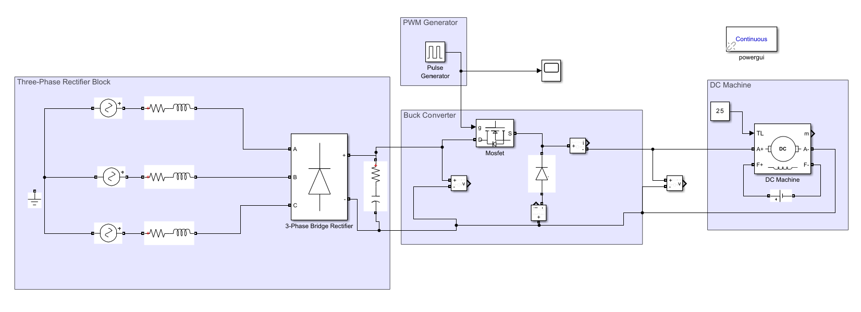

Figure 1: Proposed Design of the Term Project

# Component Selection

For the rectifier circuit, instead of using 6 separate diodes for the 3-phase full wave rectifier, a bridge rectifier module is being used for the sake of simplicity of the design and to decrease possible conduction losses. The GUO40-12NO1 3-phase bridge rectifier module is chosen for the process. Bridge rectifiers have rather high ratings in comparison with separate diode modules hence, the bridge rectifier module we have chosen satisfies the voltage and current ratings of our circuit design comprehensively.

For the switch of the buck converter, the IXFX210N30X3 MOSFET module is selected. Its voltage rating is 300V and its current rating is 210A, which is suitable for the voltage and current ratings of our design that will be presented by the simulation results in the following sections as well. 210A is not seen in steady-state, however it was chosen to overcome in-rush current and overshoot problems.

For the free-wheeling diode of the buck converter, the DSEI30-06A fast recovery diode is used which has voltage and current ratings appropriate for our design.

The parasitic inductances are implemented in the simulations considering approximate real life values of cables and PCB layout. The equivalent series resistance value for the DC-link capacitors are also added, but since we paralleled 4 capacitors this value is quite small and does not interfere with our simulations. Considering the datasheets of the MOSFET and the diode, their forwards voltage drops, on resistances and other necessary parameters (if needed) are implemented onto the simulation environment accordingly.

# Results

## Open Loop Realistic Simulations

We have constructed an open-loop buck converter topology in MATLAB Simulink as seen in Figure 2 which is connected to the output of a bridge rectifier having an average output voltage value of 257 V, the waveform of the rectifier output voltage is shown in Figure 3. The steady state waveform of the rectifier output voltage is given in Figure 4 which has a 10% ripple voltage with a DC-link capacitor of 920 uF that has been implemented using four parallel capacitors as seen in PCB design.

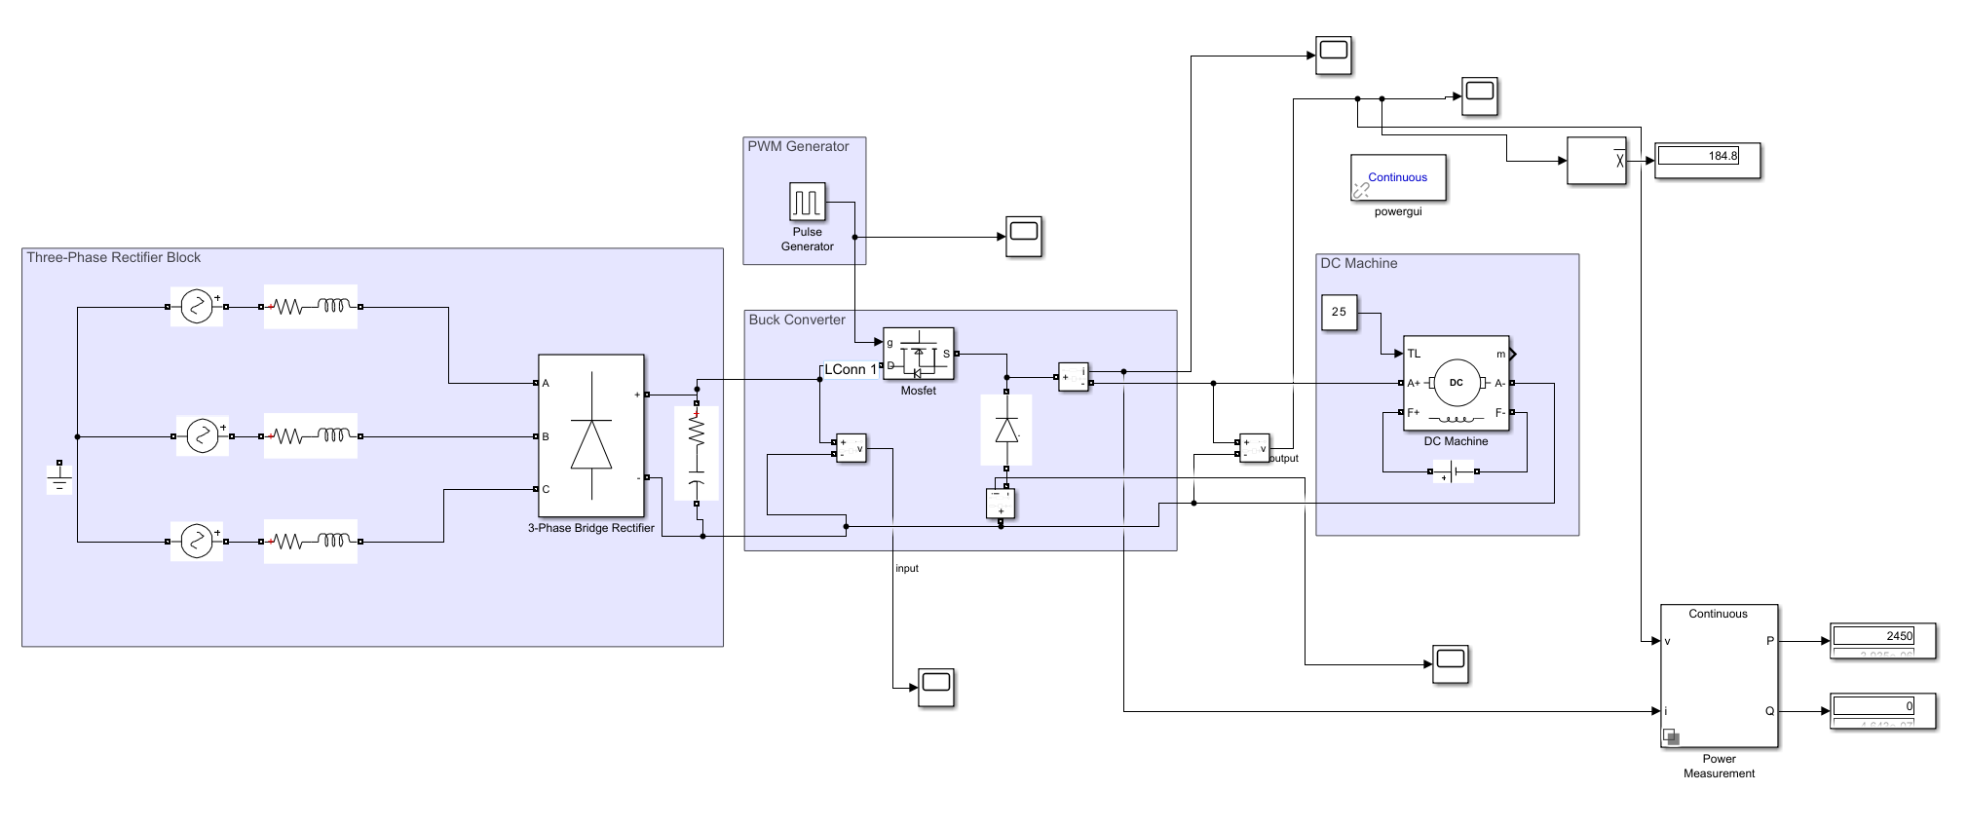

Figure 2: Open Loop Realistic Simulation Schematic

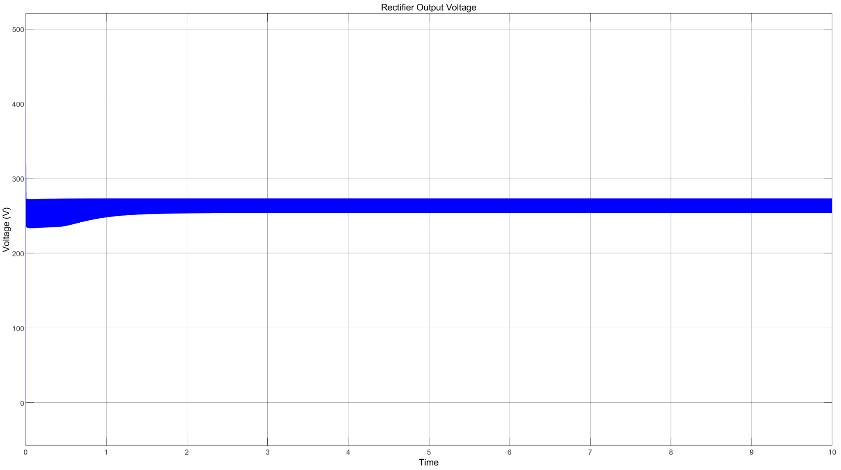

Figure 3: Rectifier Output Voltage Waveform

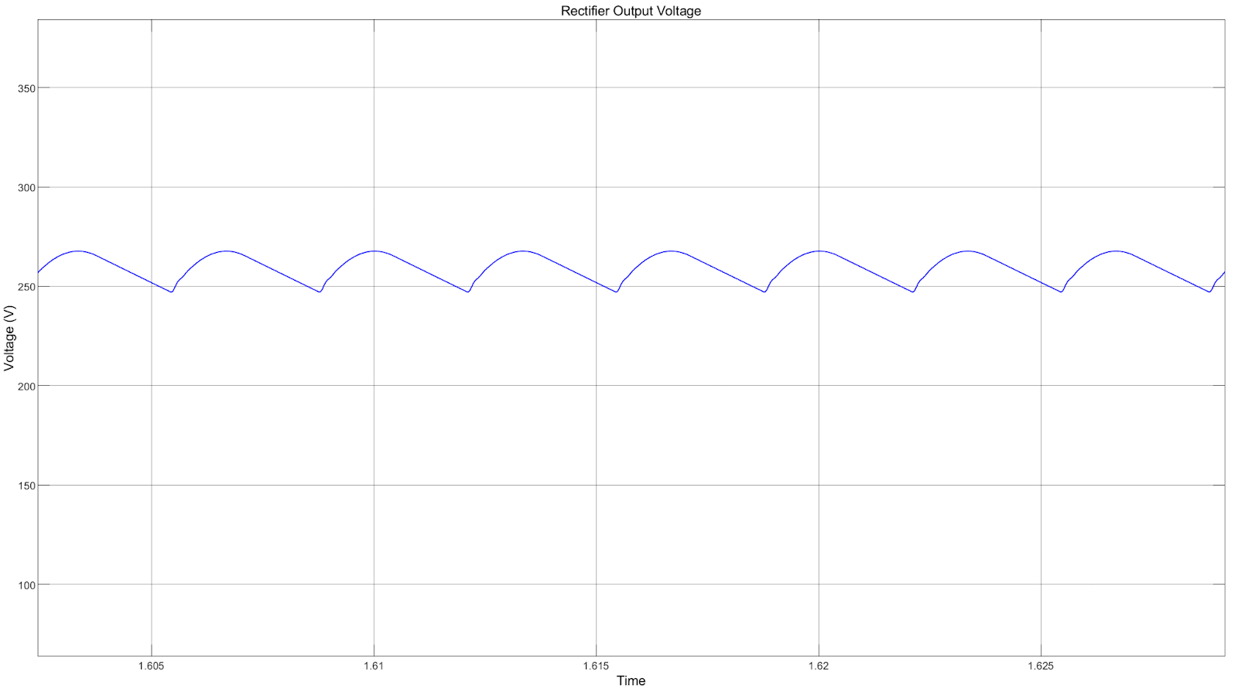

Figure 4: Rectifier Output Voltage Waveform Closed Up Version

As seen in Figure 5, the output voltage of the buck converter is approximately equal to 180 V as expected. Constant output voltage is not observed since there is no LC filter present in the circuit topology.

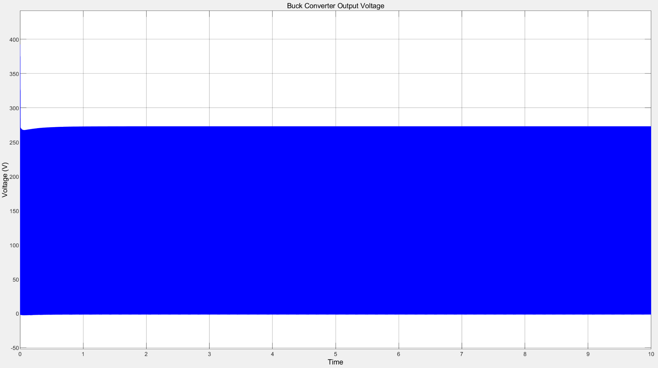

Figure 5: Buck Converter Output Voltage Waveform

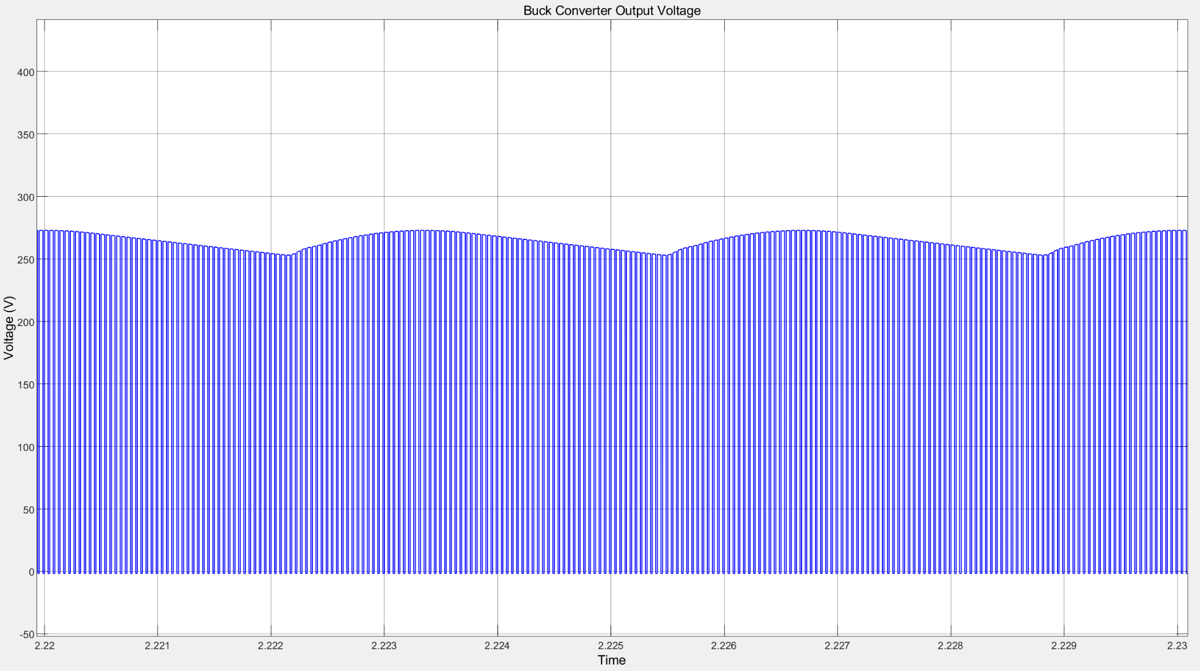

Figure 6: Buck Converter Output Voltage Waveform Close Up Version

Figure 6 shows a more close up look of the buck converter output voltage where the changes according to the duty cycle can be observed more clearly. The lack of an LC filter results in high ripple simulation results however, since the DC machine is an RL load itself, LC filter to the end of the buck converter is not added.

As we can see in Figure 7, the output current initially goes to rather high values initially for a short amount of time since there is no control loop existing in the circuit that has control over the output current. However, in steady state, the output current converges to approximately 13.2 A which provides the 2.45 kW output power seen in Figure 8 and is an acceptable value.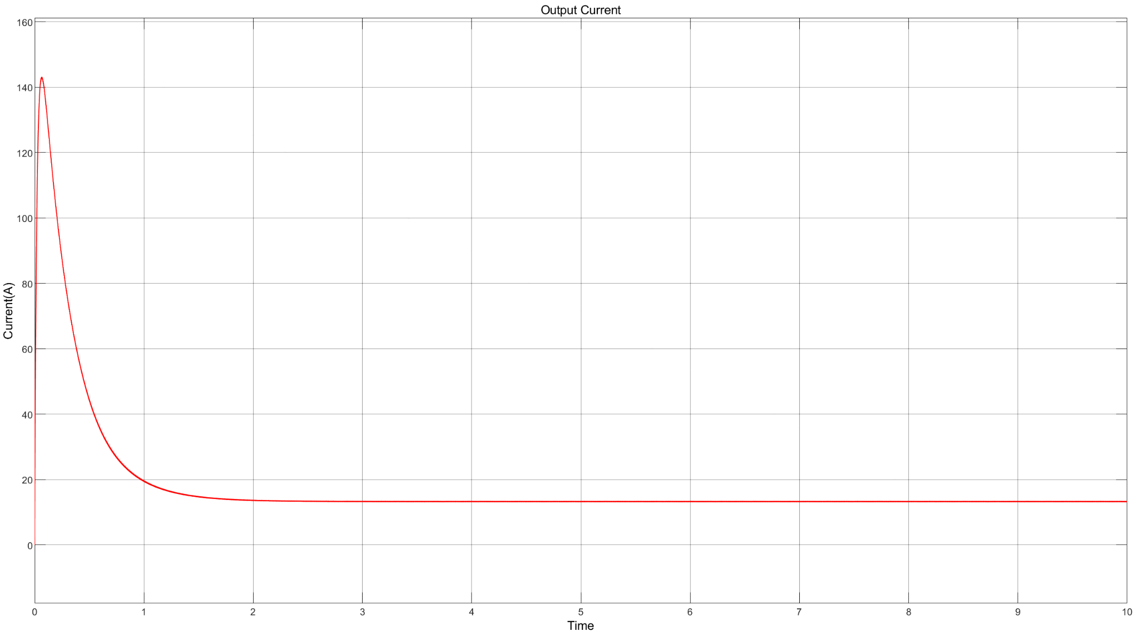

Figure 7: Buck Converter Output Current Waveform

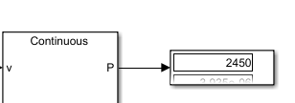

Figure 8: Output Power Calculation Result

It can be observed from Figure xx, the diode current is approximately 13.2 A in steady state, so it can be said it has a reasonable value for our diode selection which has a 37.5 A current rating. 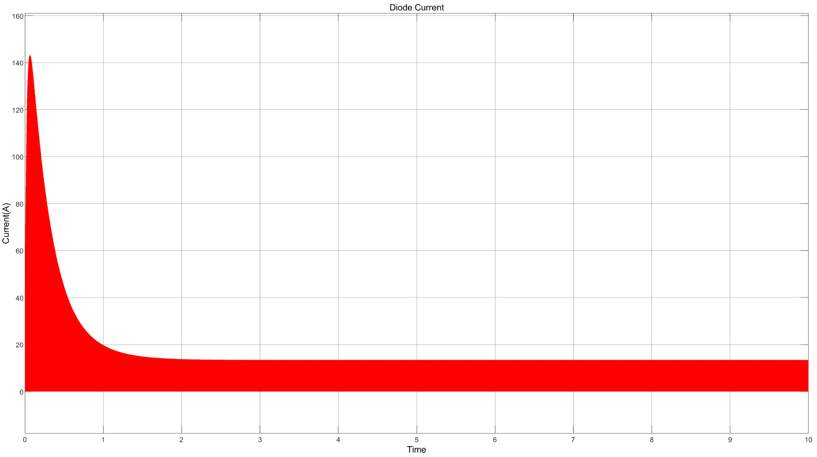

Figure 9: Free Wheeling Diode Current Waveform

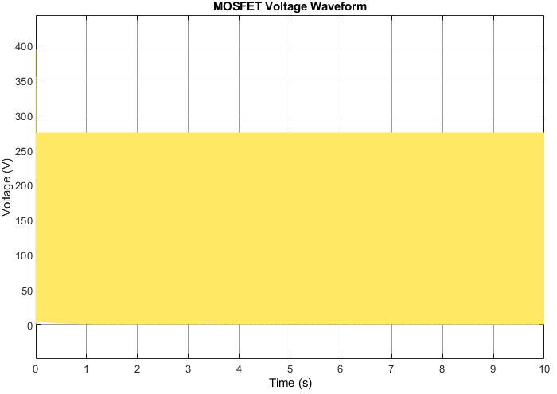As it can be seen in Figure 10, the drain to source voltage of the MOSFET is equal to between 0-275 V in steady state. Therefore, the interval of the MOSFET voltage is within the voltage rating limit for our MOSFET selection which has a drain to source voltage rating of 300 V.

Figure 10: MOSFET Output Voltage Waveform

All the simulations done with adding realistic values of the selected components in Simulink. The MOSFET in the .slx file has Rds_on=33 mΩ, Vf,internal diode=1.2 V. The diode in the .slx file has Ron = 8.5 mΩ Vf = 1.52 V. The bridge rectifier in the .slx file has Vf = 1.28 V.

However, at this point it should be considered that the motor is not being controlled using a closed loop controller. For obtaining more smooth and component-safe results, a controller topology will be presented in the next section. The closed loop implementation will be used to have control over the speed of the machine.

## Closed Loop Control Realistic Simulations

Figure 11: Closed Loop Schematic of the DC Motor Driver

The closed loop DC motor driver in Figure 11 has a feedback that can compare the reference 180 V with the current measured output voltage and keeps it constant by modifying the PWM constantly. The output voltage waveform is given in Figure 12.

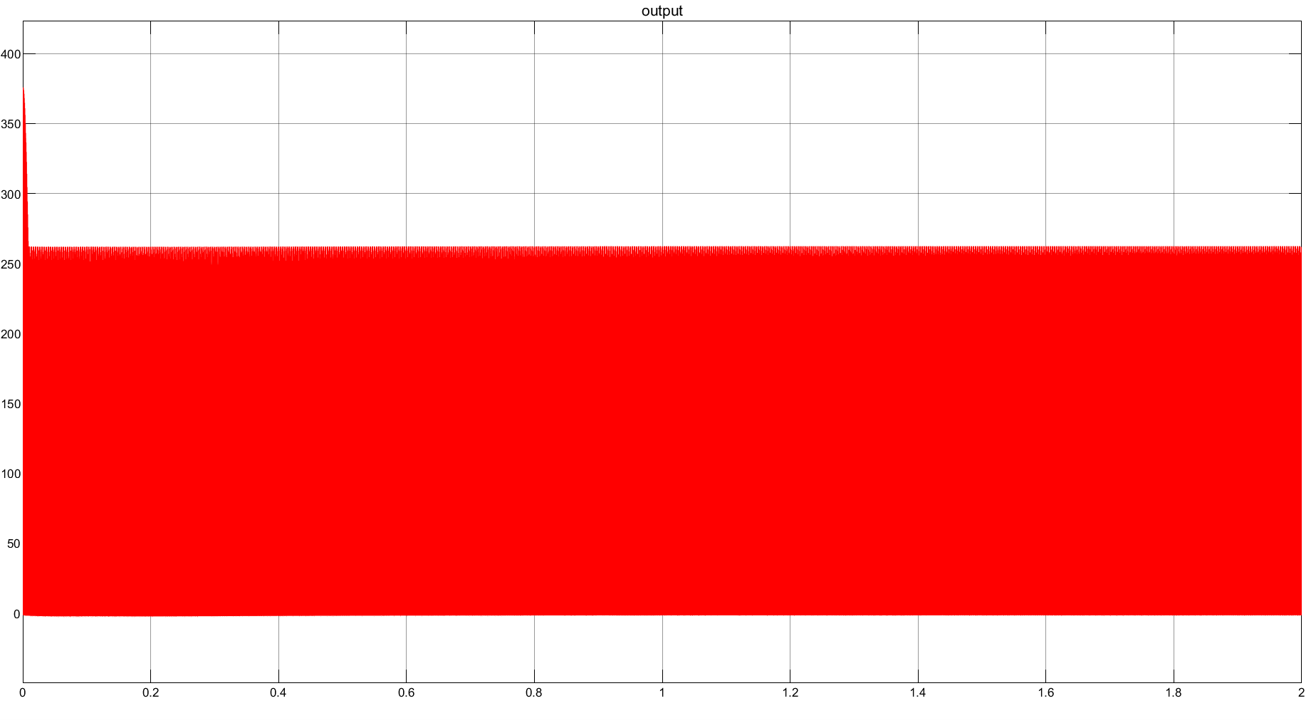

Figure 12: Output Voltage Waveform of the Closed Loop Circuit

### 

### Transfer Function Calculation using System Identification Tool in MatLab

In this section, we calculated the system's transfer function using MatLab's System Identification Toolbox. Our goal is to maintain a constant voltage at the output of the buck converter, so ensuring that the motor operates at a steady speed at its rated speed value. In the Figures 13, 14, 15, 16 and 17, we explain step by step how we calculated the transfer function. After determining the transfer function, we selected the parameters for the PID controllers integrated into the system, and as a result of these calculations, we maintained a steady output voltage.

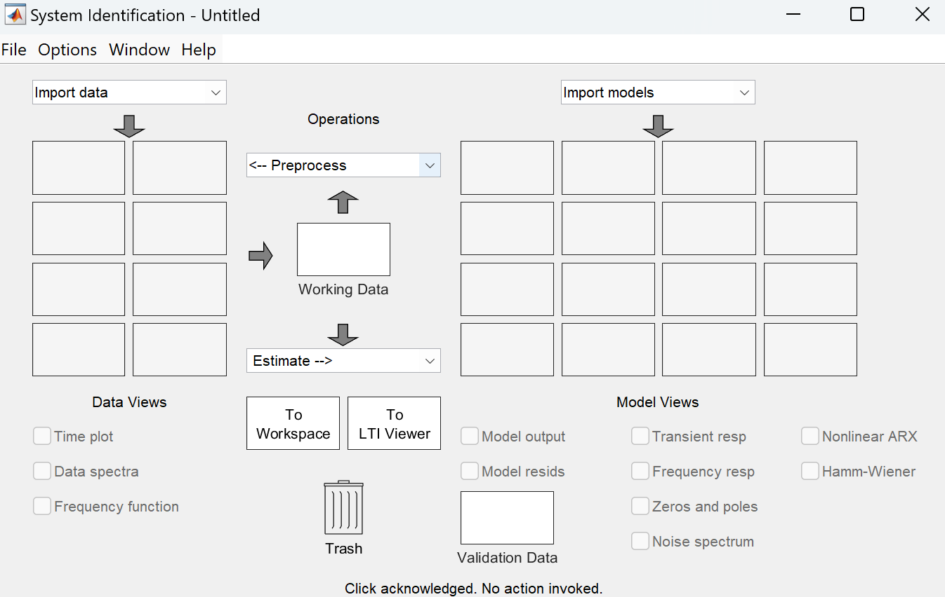

Figure 13: System Identification Step 1

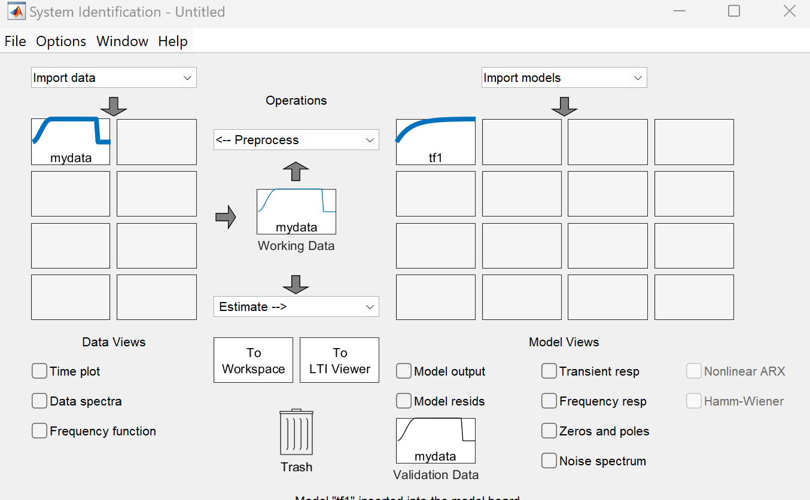

Figure 14: System Identification Step 2

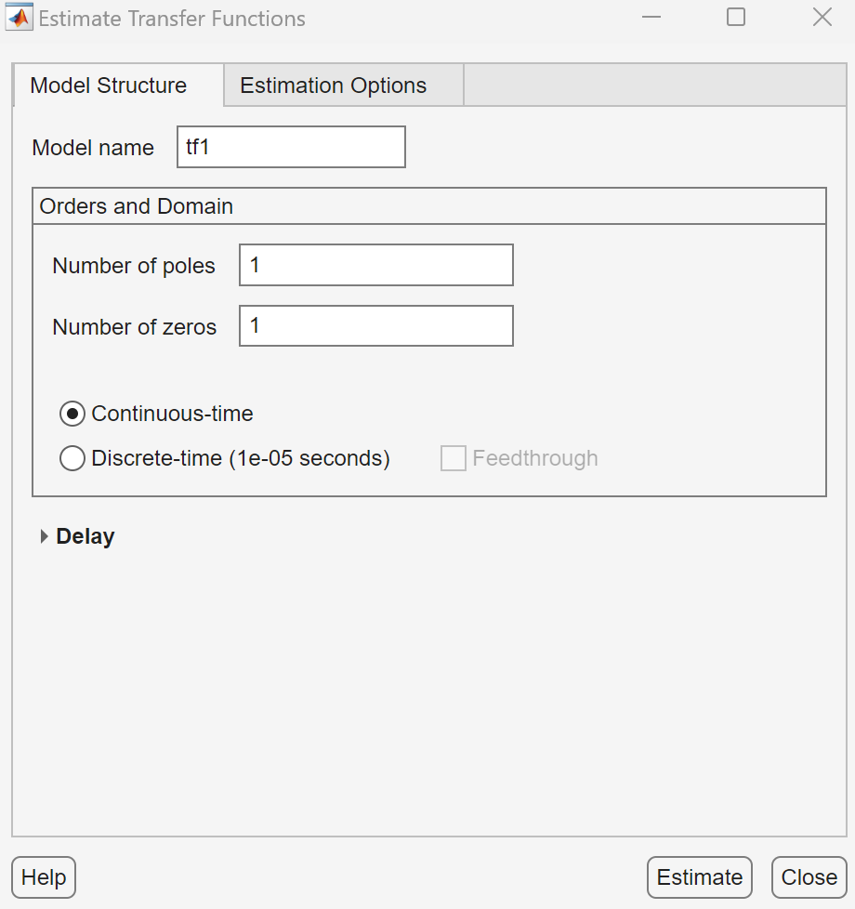

Figure 15: Pole and Zero Identification Interface Step 3

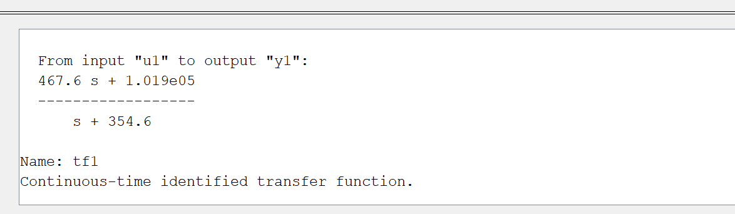

Figure 16: Resultant Transfer Function Step 4

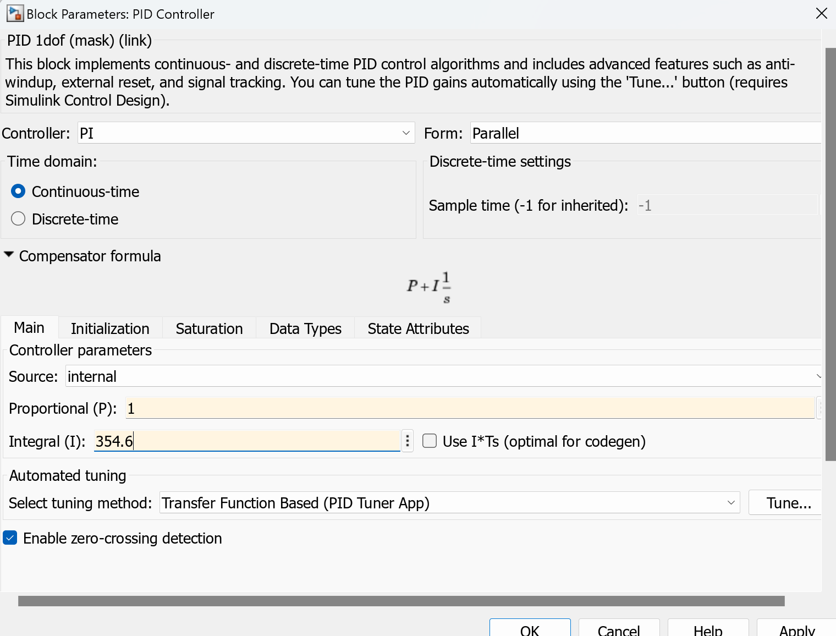

Figure 17: Determination of PI Controller Parameters Step 5

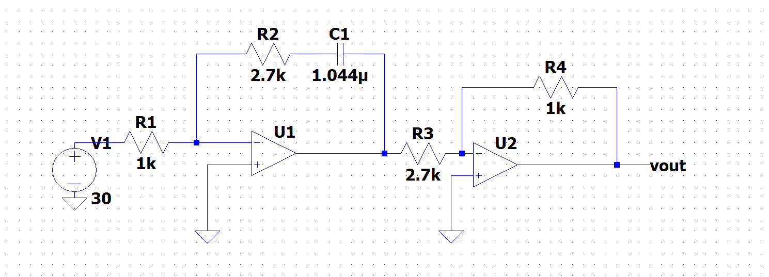

Figure 18: Analog PI Controller Circuit Schematic

$T(s)=\frac{R_{4}}{R_{3}}× \frac{R_{2}}{R_{1}}×(1 + \frac{1}{R_{2}C_{2}×S})$**(1)**

$T(s)=s+ 354.6$**(2)**

We can refer to the circuit in Figure 18 as a PI Analog Controller. The equation provided in $Equation 1$ is the system's transfer function. As a result of our calculations in MatLab, we determined the values of the resistors and capacitors in this circuit, so matching the value of the transfer function to our desired value $Equation 2$.

# PCB Design

The schematics of the PCB design of the project can be seen in Figure 18.

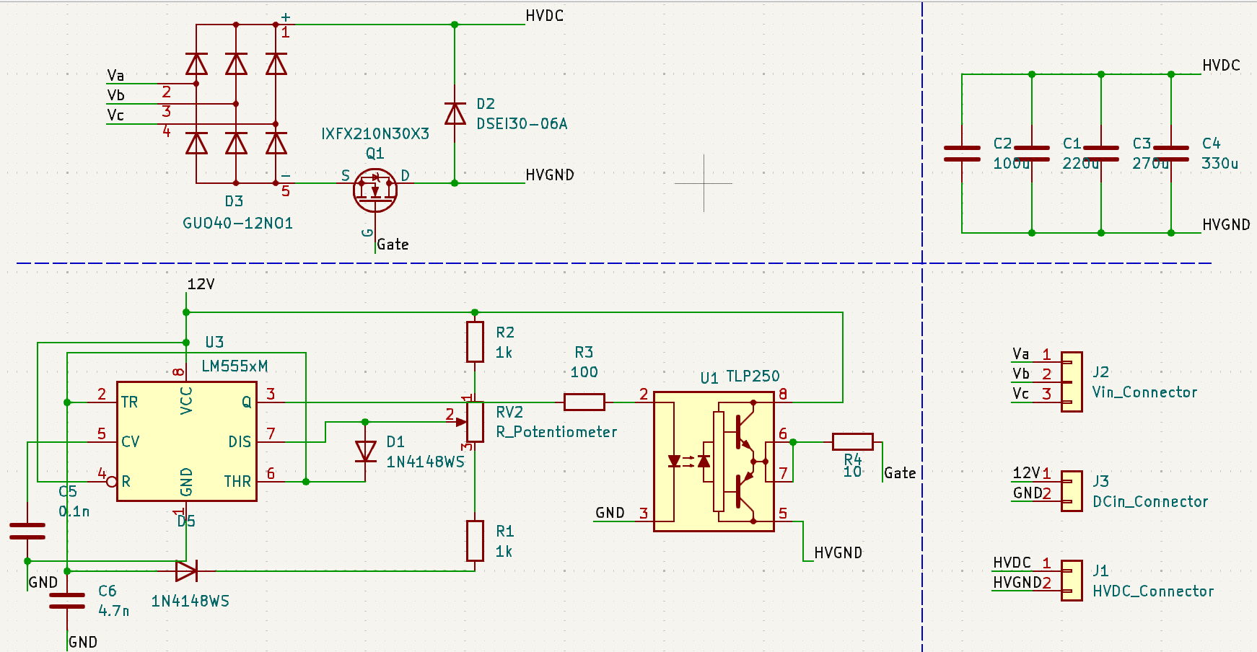

Figure 19: Schematics of the PCB

The board layout can be seen in Figure 19.

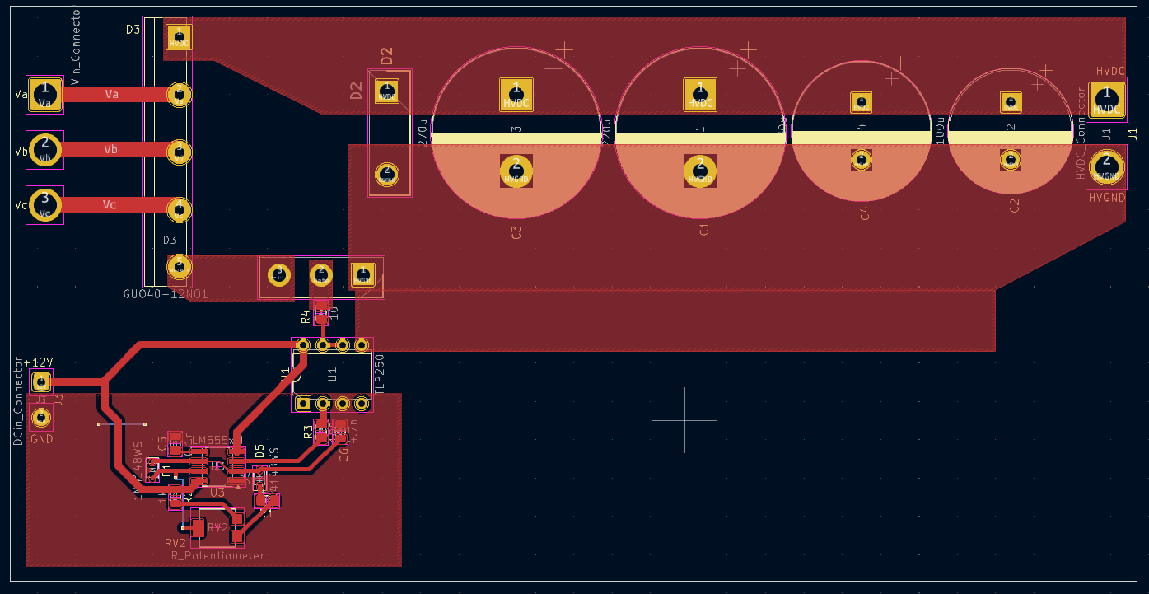

Figure 20: Board Layout of the PCB

3D View of the PCB can be seen in Figures 20 and 21.

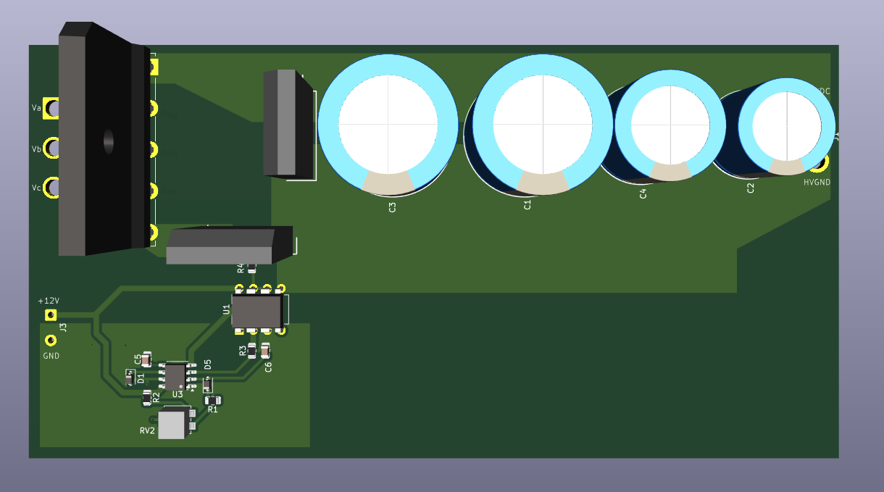

Figure 21: 3D Model of the PCB From Top

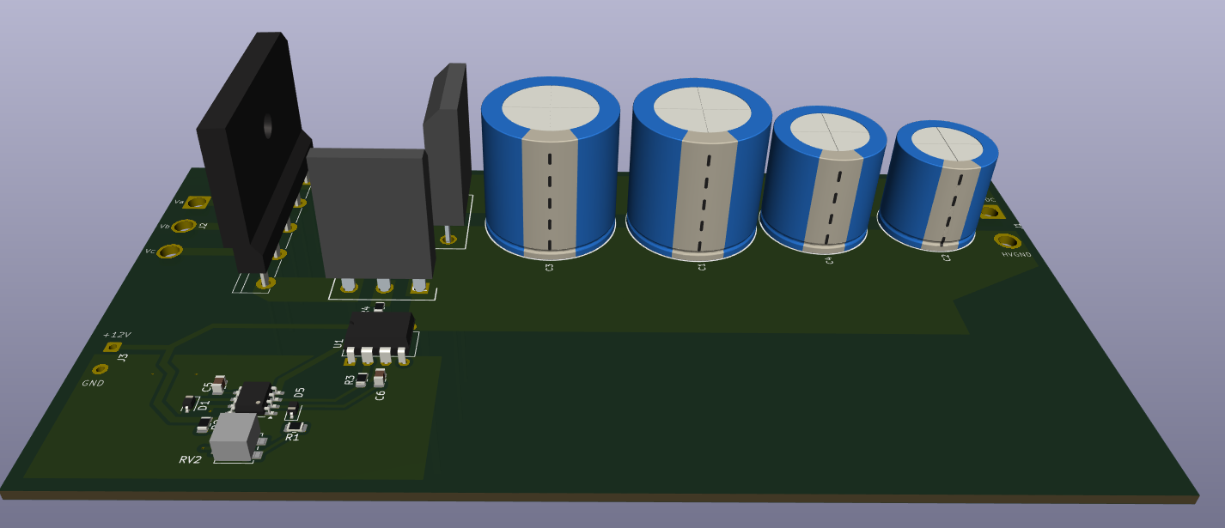

Figure 22: 3D Model of the PCB From the Side

Representative connectors are used in the design. 4 parallel capacitors are a solution for ESR and ESL issues. Ground and power planes along with shorter and thicker traces were used to reduce parasitic inductances. A mosfet gate resistance of 10 Ω is implemented. RV2 potentiometer is used to adjust the duty cycle of the 555 Timer which is implemented for soft-start or output voltage adjustments. Isolation between high voltage and signal grounds is obtained by the use of TLP250 optocoupler. 3D models of the components are also provided for visualization.

# Conclusion

In this report; aim of the project, design and topology choices, PCB design architecture and the results for both open-loop and closed-loop simulations were provided. The topology choice was finalized as a three-phase rectifier and a buck converter. The buck converter’s MOSFET is controlled using a 555 Timer with an optocoupler for isolation. Only output capacitors were implemented since the DC Motor load has internal inductances which causes the filter inductors to become obsolete. Furthermore, results of LTSpice simulations which implement gate driving processes along with Simulink simulations for PI closed-loop control were presented. Finally, the PCB design process has been briefly explained and the visuals for schematics, board layout and 3D Model were given.